U2 - 11 O Clock Tick Tock [KEY: Eb min – Tune ½ step down]
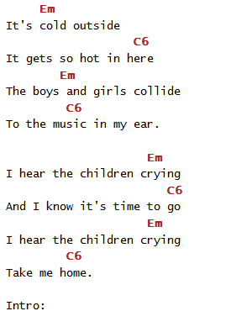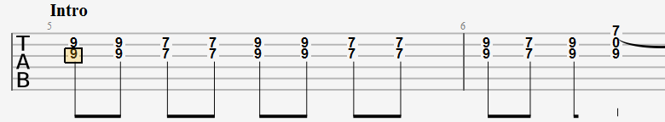
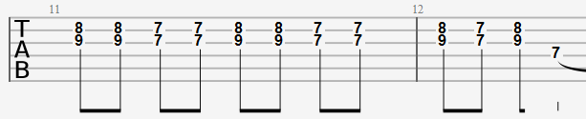
Bass (Em); Guitar (Esus4 arpeggio)
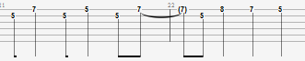
Bass (C); Guitar (A6sus4 arpeggio)
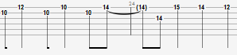
INTERLUDE
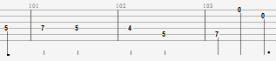

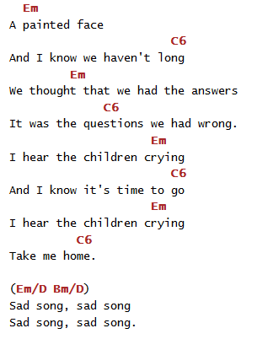
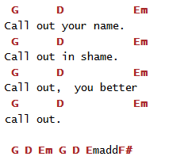
STRUCTURE
- MainRiff x2
- Verse+Chorus 1 [It's cold outside...
I hear the children crying...]
- MainRiff x1
- Verse+Chorus 2 [A painted face...
I hear the children crying...]
- Harmonics [SadSong…]
- MainRiff x2
- Chorus x2 with Vocal SKAT [la la la la] Guit Arp
- Harmonics [SadSong…]
- MainRiff x2
- Interlude (on D string) x 2 + SOLO Part1
- Harmonics Big-Ben [Call out your name...]
- Interlude (on D string) x 2 + SOLO Part2
- Interlude (on D string) x 2 (Close with Emadd9)

