**U2 - BAD [Key D Maj]**

**INTRO: Asus4 A Asus4 A Dsus2 D Dsus2 D (x2)**

**VERSE 1: if you twist and turn away**

**(Guitar A) if you tear yourself in two again**

**if i could yes i would**

**if i could i would let it go**

**surren - der dislocate**

**(Asus4) A Asus4 A Dsus2 D Dsus2 D**

**VERSE 2: if i could throw this lifeless**

**life - line to the wind Leave this**

**heart of clay, see you walk, walk away**

**D A D**

**into the night and through the rain**

**A D Dsus2 D**

**into the half-light and through the flame**

**VERSE 3: if i could through myself**

**set your spirit free**

**i'd lead your heart away**

**see you break, break away**

**into the li - ight and to the day**

**BRIDGE 1a: A D**

**(Guitar B) hoo hoo, hoo hoo, hoo hoo**

**A D**

**hoo hoo, hoo hoo, hoo hoo**

**BRIDGE 1b: A D**

**to let it go and so to fade away**

**A D**

**to let it go and so to fade away**

**A D**

**CHORUS 1: i'm wide awake, i'm wide awake**

**(Guitar A G D Asus4 A Asus4 A**

**from ‘A’ wide awa - ake, i'm not slee - ping**

**chord) Dsus2 D Dsus2 D**

**oh, no, no, no**

**LINK: Asus4 A Asus4 A Dsus2 D Dsus2 D (x2)**

**VERSE 4: if you should ask then maybe**

**they'd tell you what i would say**

**true colors fly in blue and black**

**bruised silken sky and burning flag**

**BRIDGE 2: A D**

**(Guitar B) Colours crash, collide in blood shot eyes**

**A D**

**hoo hoo, hoo hoo, hoo hoo**

**A**

**if i could you know i would**

**D A**

**if i could i would let it go**

**D A D**

**MIDDLE: this desperation, dislocation, separation**

**A**

**condemnation, revelation, in temptation**

**D**

**isolation, desolation**

**A D**

**BRIDGE 3: let it go and so fade away**

**A D**

**to let it go, oh yeah, and so fade away**

**A D**

**to let it go, oh lord, and so to fade away**

**(Guitar FINAL only LIVE)**

**A D**

**CHORUS 2: i'm wide awake, i'm wide awake**

**(Guitar A G D Asus4 A Asus4 A**

**from ‘A’ wide awa - ake, i'm not slee - ping**

**chord) Dsus2 D Dsus2 D**

**oh, no, no, no**

**OUTRO: Asus4 A Asus4 A Dsus2 D Dsus2 D**

(fade out or finish on A)

**VERSE - GUITAR scheme A - (Asus4 A Asus4 A Dsus2 D Dsus2 D)**

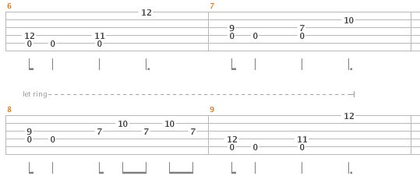

**BRIDGE, MEEDLE & CHORUS - GUITAR scheme B - ( A D)**

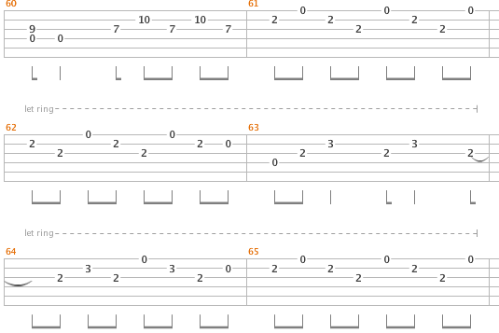

**FINAL (ONLY LIVE VERSION) - from the End of Bridge2 till End of Chorus2, than in OUTRO**