**I Still haven't found what I'm looking for - U2 [Db Maj original Tune]**

**INTRO Guit Crunch on Chords + Guit with strong Echo**

**Verse 1**

**[D]I have climbed the highest mountains**

**[D]I have run through the fields**

**Only to [G]be with you Only to [D]be with you**

**Verse 2**

**I have [D]run I have crawled**

**[D]I have scaled these city walls**

**these city [G]walls Only to [D]be with you**

***{c:Chorus}***

**But I [A]still haven't [G]found**

**What I'm [D]looking for**

**But I [A]still haven't [G]found**

**What I'm [D]looking for**

**Verse 3 & 4 (Guit crunch + Guit tremolo)**

**I have kissed honey lips**

**Felt the healing in her fingertips**

**It burned like fire This burning desire**

**I have spoke with the tongue of angels**

**I have held the hand of a devil**

**It was warm in the night I was cold as a stone**

***{c:Chorus}***

***{BRIDGE [D] x 3 [G] x 1 [D] x 1 }***

**Verse 5 & 6**

**I believe in the Kingdom Come**

**Then all the colors will bleed into one**

**bleed into one But yes I'm still running**

**You broke the bonds You loosened the chains**

**You carried the cross And my shame**

**And my shame You know I believed it**

***{c:Chorus} X 2 {BRIDGE [D] x 3 [G] x 1 [D] x 1 }***

*The song can be played in 3 different modes, all good:*

1. *In Standard Tuning, using the CAPO at 4th FRET, and playing the song in Db Maj (original studio recording)*
2. *Tuning down Half Step and using the Free String on the Chords D, G and A*
3. *As the LIVE version on Ruttle&Hum using the CAPO at 2° FRET, and playing the song in B Maj*

**Intro (muted)** G--------7-7-7-7-7---7-7-7-7-7---------------------------------------------------

**MAIN guitar riffs used by The Edge Only Picked notes (with heavy echo @ 3/16 Left and 1/16 Right):**

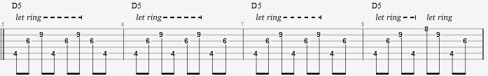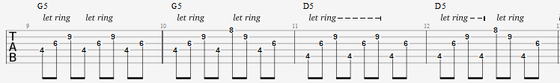

**CHORUS guitar riffs used by The Edge Only Picked notes (with heavy echo @ 3/16 Left and 1/16 Right):**

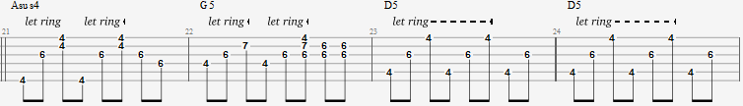

**The chords are (CAPO at 4th FRET):**

**VERSE** D5 G5 **CHORUS** Asus4 G5 D5 guitar interlude before the last verse

E---(4)---(4)--------------4-----4----4----E-2-2-2-3-3-3----3-3-3-2---2--2-2-2-3--3--3-3-3-2-

B----9-----9---------------4-----7----6----B-3-3-3-3-3-3----3-3-3-3---3--3-3-3-3--3--3-3-3-3-

G----6-----6---------------6-----6----6----G-2-2-2-2-2-2----2-2-2-2---2--2-2-2-0--0--0-0-0-2-

D---(4)----4---------------6-----4----6------------------------------

A----4----(4)--------------6-----4----4------------------------------

E--------------------------4-----------------------------------------

**INTRO** D5 crescendo fino allo stacco batteria D5 x 4 [1° C#veryhigh; 2°3°4° Dhigh]

**VERSE** D x 4 [1° Dlow; 2°3° Dhigh; 4°C#veryhigh]

G x 2 [1° Dhigh; 2° C#veryhigh] D x 2 [1° Dhigh; 2° C#veryhigh]